Traditional Christmas Dish
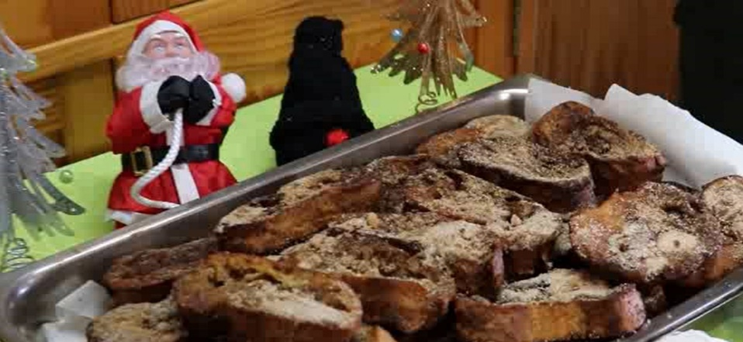

French toast’s Receipt - Portugal  Ingredients  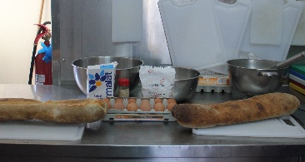  Eggs  Milk  Sugar  Cinnamon  Bread  Oil  Cut the bread in thick slices. Mix the milk with a little bit of sugar and cinnamon. Then, beat the eggs in a bowl. Heat the oil in a frying pan, while the bread wetlooks in milk. After it’s wetlooked, put the bread in the beaten eggs and then put it in the frying pan. Once the French toasts look golden, take them out of the frying pan and lay them on absorbent paper, then sprinkle them with cinnamon and sugar. | Receita das Rabanadas - Portugal  Ingredientes  Ovos  Leite  Açúcar  Canela em pó  Óleo  Cacete  Cortar o cacete em fatias grossas. Misturar o leite com um pouco de açúcar e de canela. De seguida, bater os ovos numa taça. Por numa frigideira larga o óleo a aquecer, enquanto o pão está a demolhar no leite. Depois de demolhado passar o pão pelo ovo batido e colocar na frigideira. Quando as rabanadas estiverem douradas, retirar da frigideira, colocar num tabuleiro com papel absorvente e polvilhar com canela e açúcar.

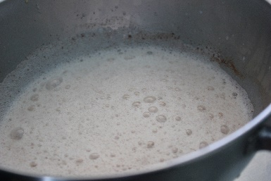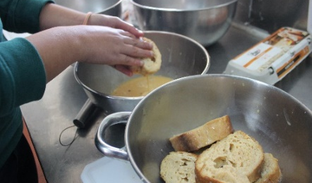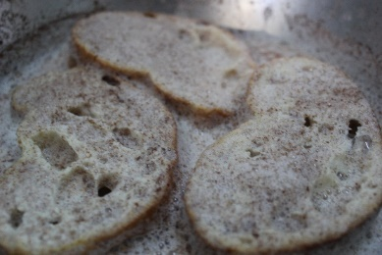
The entrepreneurship team of 10th grade students wrote the recipe, cooked and prepared the video
FAMMous Cookies: Ana Rodrigues, Francisco Figueiredo, Mafalda Lima e Matilde Monteiro

